WPT System Report

# 1. Introduction

This report describes the architecture and working of a **Wireless Power Transfer (WPT) system** used to deliver electrical power from a ground-based grid supply to a moving receiver without physical contact. The system is designed for applications such as guided mobility platforms, where eliminating mechanical power connectors reduces wear, improves reliability, and enables continuous operation. The report explains the **complete power flow from the electrical grid to the receiver (RX) coils**, along with the **TX–RX subsystems and cloud-based monitoring/control integration**.

# 2. System Level Overview

The WPT system is divided into four major subsystems:

* Grid and Power Conditioning Subsystem
* Transmitter (TX) Subsystem
* Receiver (RX) Subsystem
* Control, Communication, and Cloud Subsystem

Electrical power flows unidirectionally from the grid to the vehicle through electromagnetic coupling, while control and monitoring data flow bidirectionally through wired and wireless communication links.

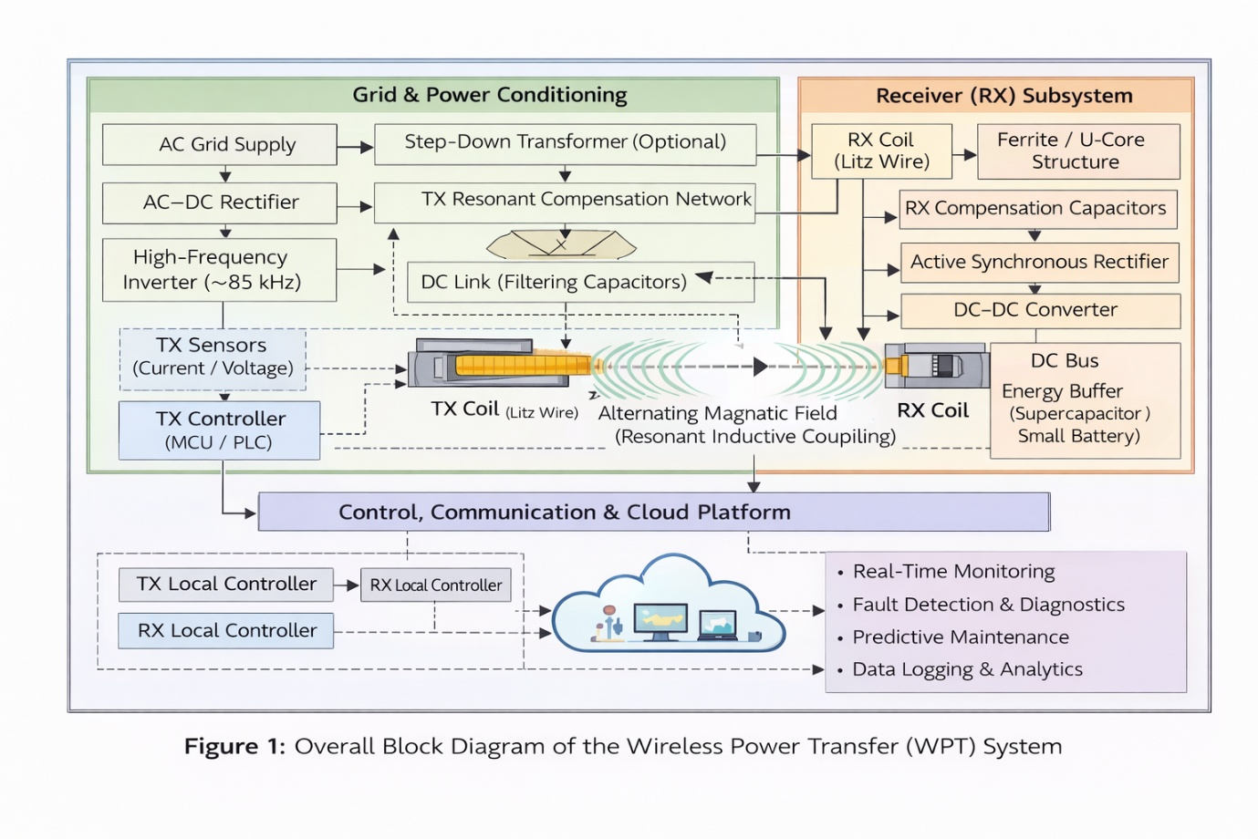

#### Figure 1: Overall Block Diagram of the Wireless Power Transfer (WPT) System

# 3. Power Flow from Grid to RX Coils

## 3.1 Grid Power Input

The primary power source for the system is the **AC electrical grid**. Power is supplied from a dedicated substation or power room located along the guideway or infrastructure.

## 3.2 Power Conditioning and Conversion

Before wireless transmission, grid power is conditioned through the following stages:

* Step-down transformer (if required)
* AC–DC rectifier
* DC link with filtering capacitors
* High-frequency inverter

The inverter converts DC power into **high-frequency AC (typically ~85 kHz)**, which is required for efficient resonant inductive coupling.

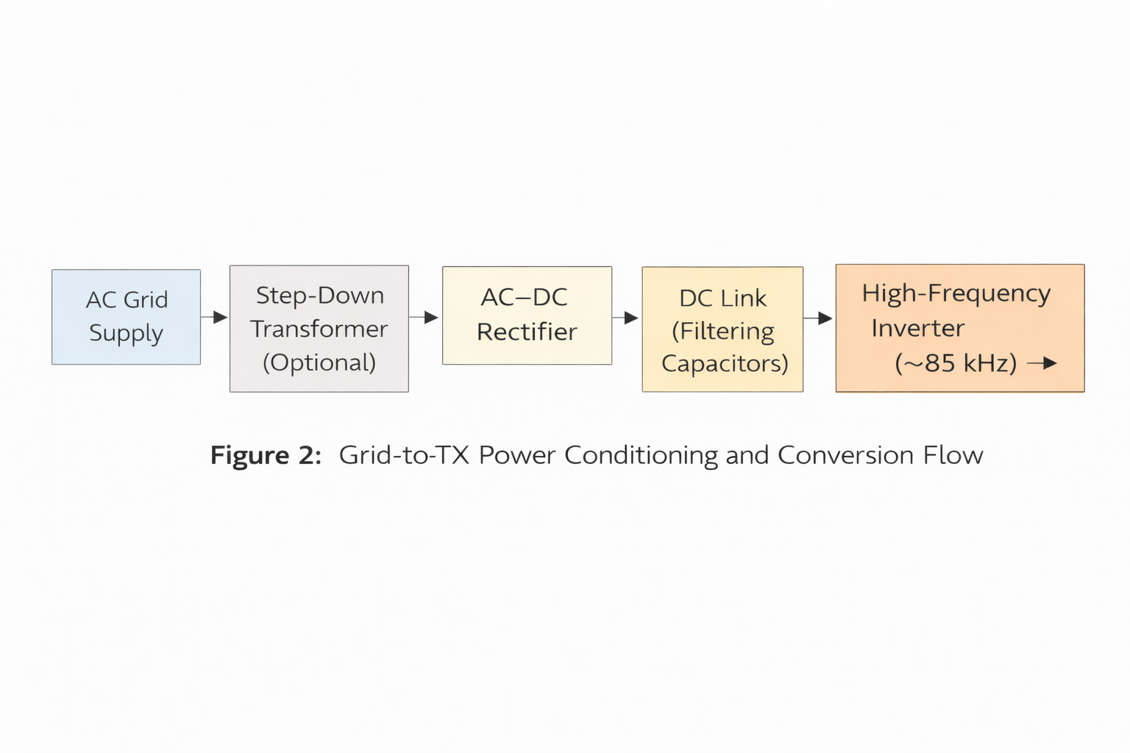

#### Figure 2: Grid-to-TX Power Conditioning and Conversion Flow

# 4. Transmitter (TX) Subsystem

## 4.1 TX Subsystem Components

* High-frequency inverter
* Resonant compensation capacitors
* TX coils (Litz wire based)
* Ferrite backing and magnetic shielding
* Current and voltage sensors
* Local TX controller (MCU/PLC)

## 4.2 TX Working Principle

The inverter excites the TX coil at its resonant frequency, producing a strong alternating magnetic field. This magnetic field propagates across the air gap and couples inductively with the receiver coil. Power transfer occurs without any physical electrical contact.

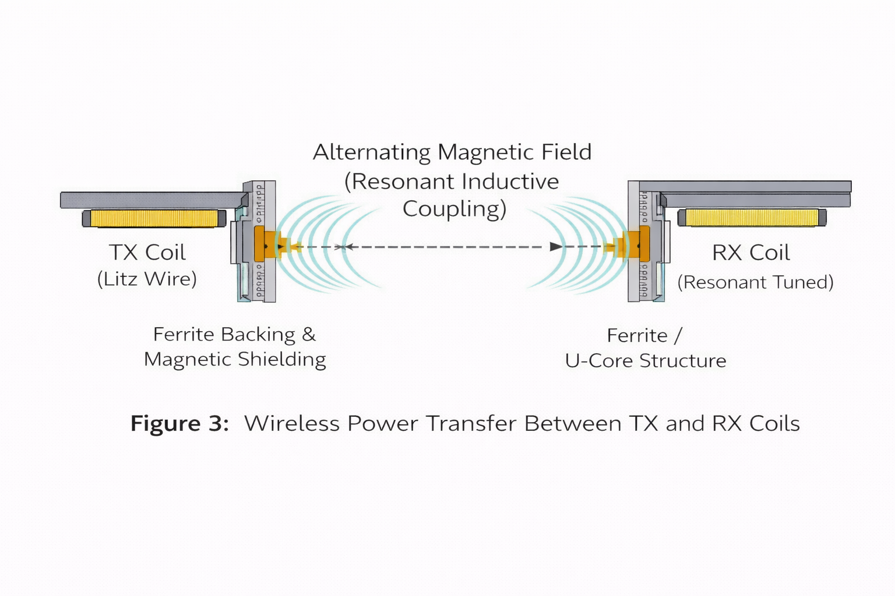

#### Figure 3: Wireless Power Transfer Between TX and RX Coils

# 5. Receiver (RX) Subsystem

## 5.1 RX Subsystem Components

* RX coil (tuned to TX frequency)
* Ferrite core or U-core structure
* Compensation capacitors
* Active synchronous rectifier
* DC–DC converter
* DC bus and energy buffer (supercapacitors or small battery)
* Protection and isolation circuitry

## 5.2 RX Working Principle

The alternating magnetic field generated by the TX coil induces an AC voltage in the RX coil. This AC power is:

1. Rectified into DC using an active rectifier
2. Regulated using a DC–DC converter
3. Distributed via a DC bus to onboard loads such as:
   * Electromagnetic suspension (EMS) systems
   * Control electronics and sensors

The final output of the RX subsystem is regulated DC power on the vehicle DC bus, which supplies the EMS system and onboard electronics.

#### 

#### Figure 4: RX-Side Power Processing and DC Distribution

# 6. Control, Monitoring, and Cloud Subsystem

## 6.1 Local Control

* TX controllers regulate inverter output and coil activation
* RX controllers manage rectification, voltage regulation, and load distribution
* Sensors continuously monitor voltage, current, temperature, and coupling efficiency

## 6.2 Cloud Integration

Operational data from TX and RX subsystems is transmitted to a **cloud platform** via wired or wireless communication. The cloud system enables:

* Real-time monitoring of power transfer efficiency
* Fault detection and diagnostics
* Predictive maintenance
* Data logging and performance analytics

Control commands and configuration updates can also be sent from the cloud to local controllers.

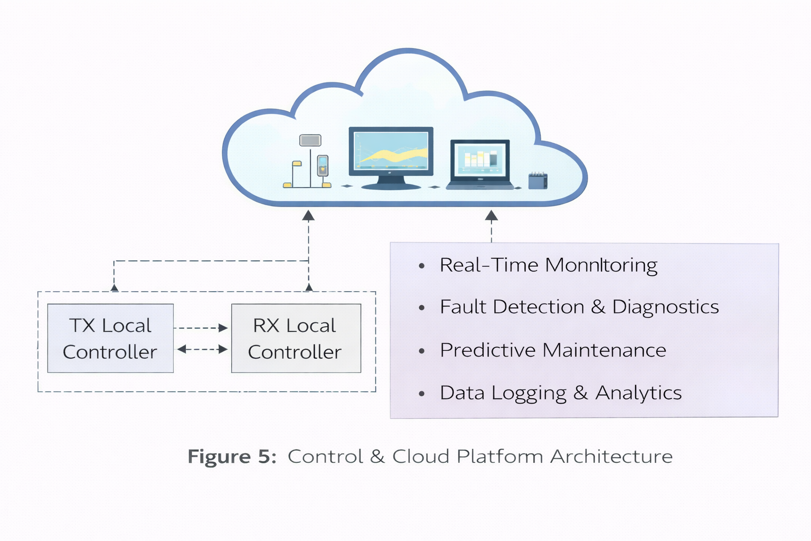

#### Figure 5: Control & Cloud Platform Architecture

# 7. Subsystem Summary (Component List)

### Grid & Power Conditioning

* AC grid supply
* Transformer
* Rectifier
* DC link capacitors
* High-frequency inverter

### TX Subsystem

* TX coils
* Resonant capacitors
* Ferrite backing
* Sensors
* Local controller

### RX Subsystem

* RX coils
* Ferrite/U-core
* Rectifier
* DC–DC converter
* DC bus and energy buffer

### Control & Cloud

* Local controllers (TX & RX)
* Communication modules
* Cloud server and dashboard

# 8. Conclusion

The proposed WPT system enables efficient, contactless power delivery from a stationary grid source to a mobile receiver. By combining resonant inductive coupling with active power electronics and cloud-based monitoring, the system achieves reliable power transfer while reducing mechanical complexity and maintenance requirements. This architecture is well suited for modern guided mobility and automated transportation platforms.